1.**Display all departments from department table**.

CREATE TABLE DEPT

(

DEPTNO NUMERIC(2) CONSTRAINT DEPTNO_DEPT_PK PRIMARY KEY,

DNAME VARCHAR(14),

LOC VARCHAR(13)

);

INSERT INTO DEPT VALUES (10,'ACCOUNTING','NEW YORK');

INSERT INTO DEPT VALUES (20,'RESEARCH','DALLAS');

INSERT INTO DEPT VALUES (30,'SALES','CHICAGO');

INSERT INTO DEPT VALUES (40,'OPERATIONS','BOSTON');

Ans: SELECT DNAME FROM DEPT;

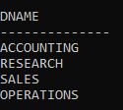

2.Display all employees from employee table.

CREATE TABLE EMP

(

EMPNO NUMERIC(4) CONSTRAINT EMPNO_EMP_PK PRIMARY KEY,

ENAME VARCHAR(10),

JOB VARCHAR(9),

MGR NUMERIC(4),

HIREDATE DATE,

SAL NUMERIC(7,2),

COMM NUMERIC(7,2),

DEPTNO NUMERIC(2) CONSTRAINT DEPTNO_DEPT_FK REFERENCES DEPT(DEPTNO)

);

INSERT INTO EMP VALUES (7369,'SMITH','CLERK',7902,'17-DEC-80',800,NULL,20);

INSERT INTO EMP VALUES (7499,'ALLEN','SALESMAN',7698,'20-FEB-81',1600,300,30);

INSERT INTO EMP VALUES (7521,'WARD','SALESMAN',7698,'22-FEB-81',1250,500,30);

INSERT INTO EMP VALUES (7566,'JONES','MANAGER',7839,'02-APR-81',2975,NULL,20);

INSERT INTO EMP VALUES (7654,'MARTIN','SALESMAN',7698,'28-SEP-81',1250,1400,30);

INSERT INTO EMP VALUES (7698,'BLAKE','MANAGER',7839,'01-MAY-81',2850,NULL,30);

INSERT INTO EMP VALUES (7782,'CLARK','MANAGER',7839,'09-JUN-81',2450,NULL,10);

INSERT INTO EMP VALUES (7788,'SCOTT','ANALYST',7566,'19-APR-87',3000,NULL,20);

INSERT INTO EMP VALUES (7839,'KING','PRESIDENT',NULL,'17-NOV-81',5000,NULL,10);

INSERT INTO EMP VALUES (7844,'TURNER','SALESMAN',7698,'08-SEP-81',1500,0,30);

INSERT INTO EMP VALUES (7876,'ADAMS','CLERK',7788,'23-MAY-87',1100,NULL,20);

INSERT INTO EMP VALUES (7900,'JAMES','CLERK',7698,'03-DEC-81','950',NULL,30);

INSERT INTO EMP VALUES (7902,'FORD','ANALYST',7566,'03-DEC-81',3000,NULL,20);

INSERT INTO EMP VALUES (7934,'MILLER','CLERK',7782,'23-JAN-82',1300,NULL,10);

Ans:SELECT ENAME FROM EMP;

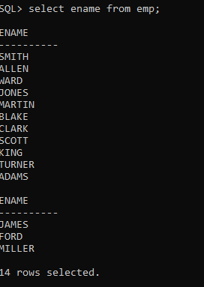

**3.SELECT Employee in Dept 30.**

CREATE TABLE EMP

(

EMPNO NUMERIC(4) CONSTRAINT EMPNO_EMP_PK PRIMARY KEY,

ENAME VARCHAR(10),

JOB VARCHAR(9),

MGR NUMERIC(4),

HIREDATE DATE,

SAL NUMERIC(7,2),

COMM NUMERIC(7,2),

DEPTNO NUMERIC(2) CONSTRAINT DEPTNO_DEPT_FK REFERENCES DEPT(DEPTNO)

);

INSERT INTO EMP VALUES (7369,'SMITH','CLERK',7902,'17-DEC-80',800,NULL,20);

INSERT INTO EMP VALUES (7499,'ALLEN','SALESMAN',7698,'20-FEB-81',1600,300,30);

INSERT INTO EMP VALUES (7521,'WARD','SALESMAN',7698,'22-FEB-81',1250,500,30);

INSERT INTO EMP VALUES (7566,'JONES','MANAGER',7839,'02-APR-81',2975,NULL,20);

INSERT INTO EMP VALUES (7654,'MARTIN','SALESMAN',7698,'28-SEP-81',1250,1400,30);

INSERT INTO EMP VALUES (7698,'BLAKE','MANAGER',7839,'01-MAY-81',2850,NULL,30);

INSERT INTO EMP VALUES (7782,'CLARK','MANAGER',7839,'09-JUN-81',2450,NULL,10);

INSERT INTO EMP VALUES (7788,'SCOTT','ANALYST',7566,'19-APR-87',3000,NULL,20);

INSERT INTO EMP VALUES (7839,'KING','PRESIDENT',NULL,'17-NOV-81',5000,NULL,10);

INSERT INTO EMP VALUES (7844,'TURNER','SALESMAN',7698,'08-SEP-81',1500,0,30);

INSERT INTO EMP VALUES (7876,'ADAMS','CLERK',7788,'23-MAY-87',1100,NULL,20);

INSERT INTO EMP VALUES (7900,'JAMES','CLERK',7698,'03-DEC-81','950',NULL,30);

INSERT INTO EMP VALUES (7902,'FORD','ANALYST',7566,'03-DEC-81',3000,NULL,20);

INSERT INTO EMP VALUES (7934,'MILLER','CLERK',7782,'23-JAN-82',1300,NULL,10);

ANS:

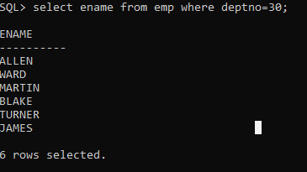i

4.List the names,numbers and departmentno of all employees.

CREATE TABLE EMP

(

EMPNO NUMERIC(4) CONSTRAINT EMPNO_EMP_PK PRIMARY KEY,

ENAME VARCHAR(10),

JOB VARCHAR(9),

MGR NUMERIC(4),

HIREDATE DATE,

SAL NUMERIC(7,2),

COMM NUMERIC(7,2),

DEPTNO NUMERIC(2) CONSTRAINT DEPTNO_DEPT_FK REFERENCES DEPT(DEPTNO)

);

INSERT INTO EMP VALUES (7369,'SMITH','CLERK',7902,'17-DEC-80',800,NULL,20);

INSERT INTO EMP VALUES (7499,'ALLEN','SALESMAN',7698,'20-FEB-81',1600,300,30);

INSERT INTO EMP VALUES (7521,'WARD','SALESMAN',7698,'22-FEB-81',1250,500,30);

INSERT INTO EMP VALUES (7566,'JONES','MANAGER',7839,'02-APR-81',2975,NULL,20);

INSERT INTO EMP VALUES (7654,'MARTIN','SALESMAN',7698,'28-SEP-81',1250,1400,30);

INSERT INTO EMP VALUES (7698,'BLAKE','MANAGER',7839,'01-MAY-81',2850,NULL,30);

INSERT INTO EMP VALUES (7782,'CLARK','MANAGER',7839,'09-JUN-81',2450,NULL,10);

INSERT INTO EMP VALUES (7788,'SCOTT','ANALYST',7566,'19-APR-87',3000,NULL,20);

INSERT INTO EMP VALUES (7839,'KING','PRESIDENT',NULL,'17-NOV-81',5000,NULL,10);

INSERT INTO EMP VALUES (7844,'TURNER','SALESMAN',7698,'08-SEP-81',1500,0,30);

INSERT INTO EMP VALUES (7876,'ADAMS','CLERK',7788,'23-MAY-87',1100,NULL,20);

INSERT INTO EMP VALUES (7900,'JAMES','CLERK',7698,'03-DEC-81','950',NULL,30);

INSERT INTO EMP VALUES (7902,'FORD','ANALYST',7566,'03-DEC-81',3000,NULL,20);

INSERT INTO EMP VALUES (7934,'MILLER','CLERK',7782,'23-JAN-82',1300,NULL,10);

Ans:SELECT ENAME,EMPNO,DEPTNO FROM EMP WHERE JOB = 'CLERK';

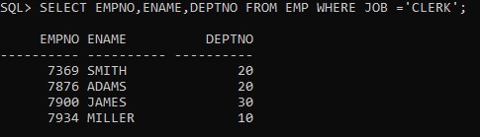

5.Find the depart numbers, and name of the employee of all dept with deptno greater than or equal to 20

CREATE TABLE EMP

(

EMPNO NUMERIC(4) CONSTRAINT EMPNO_EMP_PK PRIMARY KEY,

ENAME VARCHAR(10),

JOB VARCHAR(9),

MGR NUMERIC(4),

HIREDATE DATE,

SAL NUMERIC(7,2),

COMM NUMERIC(7,2),

DEPTNO NUMERIC(2) CONSTRAINT DEPTNO_DEPT_FK REFERENCES DEPT(DEPTNO)

);

INSERT INTO EMP VALUES (7369,'SMITH','CLERK',7902,'17-DEC-80',800,NULL,20);

INSERT INTO EMP VALUES (7499,'ALLEN','SALESMAN',7698,'20-FEB-81',1600,300,30);

INSERT INTO EMP VALUES (7521,'WARD','SALESMAN',7698,'22-FEB-81',1250,500,30);

INSERT INTO EMP VALUES (7566,'JONES','MANAGER',7839,'02-APR-81',2975,NULL,20);

INSERT INTO EMP VALUES (7654,'MARTIN','SALESMAN',7698,'28-SEP-81',1250,1400,30);

INSERT INTO EMP VALUES (7698,'BLAKE','MANAGER',7839,'01-MAY-81',2850,NULL,30);

INSERT INTO EMP VALUES (7782,'CLARK','MANAGER',7839,'09-JUN-81',2450,NULL,10);

INSERT INTO EMP VALUES (7788,'SCOTT','ANALYST',7566,'19-APR-87',3000,NULL,20);

INSERT INTO EMP VALUES (7839,'KING','PRESIDENT',NULL,'17-NOV-81',5000,NULL,10);

INSERT INTO EMP VALUES (7844,'TURNER','SALESMAN',7698,'08-SEP-81',1500,0,30);

INSERT INTO EMP VALUES (7876,'ADAMS','CLERK',7788,'23-MAY-87',1100,NULL,20);

INSERT INTO EMP VALUES (7900,'JAMES','CLERK',7698,'03-DEC-81','950',NULL,30);

INSERT INTO EMP VALUES (7902,'FORD','ANALYST',7566,'03-DEC-81',3000,NULL,20);

INSERT INTO EMP VALUES (7934,'MILLER','CLERK',7782,'23-JAN-82',1300,NULL,10);

Ans:SELECT DEPTNO,ENAME FROM EMP WHERE DEPTNO >=20;

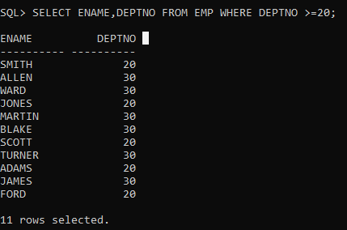

6.Find the Employees whose commission is greater than their salary.

CREATE TABLE EMP

(

EMPNO NUMERIC(4) CONSTRAINT EMPNO_EMP_PK PRIMARY KEY,

ENAME VARCHAR(10),

JOB VARCHAR(9),

MGR NUMERIC(4),

HIREDATE DATE,

SAL NUMERIC(7,2),

COMM NUMERIC(7,2),

DEPTNO NUMERIC(2) CONSTRAINT DEPTNO_DEPT_FK REFERENCES DEPT(DEPTNO)

);

INSERT INTO EMP VALUES (7369,'SMITH','CLERK',7902,'17-DEC-80',800,NULL,20);

INSERT INTO EMP VALUES (7499,'ALLEN','SALESMAN',7698,'20-FEB-81',1600,300,30);

INSERT INTO EMP VALUES (7521,'WARD','SALESMAN',7698,'22-FEB-81',1250,500,30);

INSERT INTO EMP VALUES (7566,'JONES','MANAGER',7839,'02-APR-81',2975,NULL,20);

INSERT INTO EMP VALUES (7654,'MARTIN','SALESMAN',7698,'28-SEP-81',1250,1400,30);

INSERT INTO EMP VALUES (7698,'BLAKE','MANAGER',7839,'01-MAY-81',2850,NULL,30);

INSERT INTO EMP VALUES (7782,'CLARK','MANAGER',7839,'09-JUN-81',2450,NULL,10);

INSERT INTO EMP VALUES (7788,'SCOTT','ANALYST',7566,'19-APR-87',3000,NULL,20);

INSERT INTO EMP VALUES (7839,'KING','PRESIDENT',NULL,'17-NOV-81',5000,NULL,10);

INSERT INTO EMP VALUES (7844,'TURNER','SALESMAN',7698,'08-SEP-81',1500,0,30);

INSERT INTO EMP VALUES (7876,'ADAMS','CLERK',7788,'23-MAY-87',1100,NULL,20);

INSERT INTO EMP VALUES (7900,'JAMES','CLERK',7698,'03-DEC-81','950',NULL,30);

INSERT INTO EMP VALUES (7902,'FORD','ANALYST',7566,'03-DEC-81',3000,NULL,20);

INSERT INTO EMP VALUES (7934,'MILLER','CLERK',7782,'23-JAN-82',1300,NULL,10);

Ans: SELECT ENAME FROM EMP WHERE COMM > SAL;

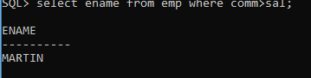

7.Find the employees whose commission is greater than 60% of their salary.

CREATE TABLE EMP

(

EMPNO NUMERIC(4) CONSTRAINT EMPNO_EMP_PK PRIMARY KEY,

ENAME VARCHAR(10),

JOB VARCHAR(9),

MGR NUMERIC(4),

HIREDATE DATE,

SAL NUMERIC(7,2),

COMM NUMERIC(7,2),

DEPTNO NUMERIC(2) CONSTRAINT DEPTNO_DEPT_FK REFERENCES DEPT(DEPTNO)

);

INSERT INTO EMP VALUES (7369,'SMITH','CLERK',7902,'17-DEC-80',800,NULL,20);

INSERT INTO EMP VALUES (7499,'ALLEN','SALESMAN',7698,'20-FEB-81',1600,300,30);

INSERT INTO EMP VALUES (7521,'WARD','SALESMAN',7698,'22-FEB-81',1250,500,30);

INSERT INTO EMP VALUES (7566,'JONES','MANAGER',7839,'02-APR-81',2975,NULL,20);

INSERT INTO EMP VALUES (7654,'MARTIN','SALESMAN',7698,'28-SEP-81',1250,1400,30);

INSERT INTO EMP VALUES (7698,'BLAKE','MANAGER',7839,'01-MAY-81',2850,NULL,30);

INSERT INTO EMP VALUES (7782,'CLARK','MANAGER',7839,'09-JUN-81',2450,NULL,10);

INSERT INTO EMP VALUES (7788,'SCOTT','ANALYST',7566,'19-APR-87',3000,NULL,20);

INSERT INTO EMP VALUES (7839,'KING','PRESIDENT',NULL,'17-NOV-81',5000,NULL,10);

INSERT INTO EMP VALUES (7844,'TURNER','SALESMAN',7698,'08-SEP-81',1500,0,30);

INSERT INTO EMP VALUES (7876,'ADAMS','CLERK',7788,'23-MAY-87',1100,NULL,20);

INSERT INTO EMP VALUES (7900,'JAMES','CLERK',7698,'03-DEC-81','950',NULL,30);

INSERT INTO EMP VALUES (7902,'FORD','ANALYST',7566,'03-DEC-81',3000,NULL,20);

INSERT INTO EMP VALUES (7934,'MILLER','CLERK',7782,'23-JAN-82',1300,NULL,10);

Ans:SELECT FROM EMP WHERE COMM >(60/100)*SAL;

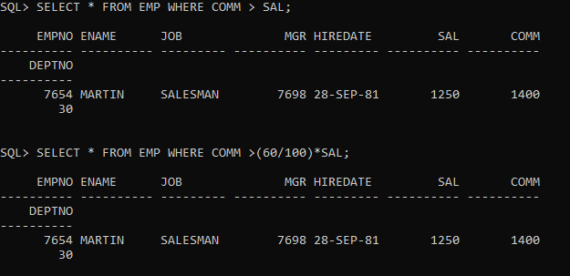

8.Find the employees whose commission is greater than 50% of their salary.

CREATE TABLE EMP

(

EMPNO NUMERIC(4) CONSTRAINT EMPNO_EMP_PK PRIMARY KEY,

ENAME VARCHAR(10),

JOB VARCHAR(9),

MGR NUMERIC(4),

HIREDATE DATE,

SAL NUMERIC(7,2),

COMM NUMERIC(7,2),

DEPTNO NUMERIC(2) CONSTRAINT DEPTNO_DEPT_FK REFERENCES DEPT(DEPTNO)

);

INSERT INTO EMP VALUES (7369,'SMITH','CLERK',7902,'17-DEC-80',800,NULL,20);

INSERT INTO EMP VALUES (7499,'ALLEN','SALESMAN',7698,'20-FEB-81',1600,300,30);

INSERT INTO EMP VALUES (7521,'WARD','SALESMAN',7698,'22-FEB-81',1250,500,30);

INSERT INTO EMP VALUES (7566,'JONES','MANAGER',7839,'02-APR-81',2975,NULL,20);

INSERT INTO EMP VALUES (7654,'MARTIN','SALESMAN',7698,'28-SEP-81',1250,1400,30);

INSERT INTO EMP VALUES (7698,'BLAKE','MANAGER',7839,'01-MAY-81',2850,NULL,30);

INSERT INTO EMP VALUES (7782,'CLARK','MANAGER',7839,'09-JUN-81',2450,NULL,10);

INSERT INTO EMP VALUES (7788,'SCOTT','ANALYST',7566,'19-APR-87',3000,NULL,20);

INSERT INTO EMP VALUES (7839,'KING','PRESIDENT',NULL,'17-NOV-81',5000,NULL,10);

INSERT INTO EMP VALUES (7844,'TURNER','SALESMAN',7698,'08-SEP-81',1500,0,30);

INSERT INTO EMP VALUES (7876,'ADAMS','CLERK',7788,'23-MAY-87',1100,NULL,20);

INSERT INTO EMP VALUES (7900,'JAMES','CLERK',7698,'03-DEC-81','950',NULL,30);

INSERT INTO EMP VALUES (7902,'FORD','ANALYST',7566,'03-DEC-81',3000,NULL,20);

INSERT INTO EMP VALUES (7934,'MILLER','CLERK',7782,'23-JAN-82',1300,NULL,10);

Ans:SELECT FROM EMP WHERE COMM >(50/100)*SAL;

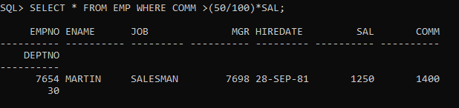

9.Find the name,job,salary of all employees in dept20 who earn more than 2000.

CREATE TABLE EMP

(

EMPNO NUMERIC(4) CONSTRAINT EMPNO_EMP_PK PRIMARY KEY,

ENAME VARCHAR(10),

JOB VARCHAR(9),

MGR NUMERIC(4),

HIREDATE DATE,

SAL NUMERIC(7,2),

COMM NUMERIC(7,2),

DEPTNO NUMERIC(2) CONSTRAINT DEPTNO_DEPT_FK REFERENCES DEPT(DEPTNO)

);

INSERT INTO EMP VALUES (7369,'SMITH','CLERK',7902,'17-DEC-80',800,NULL,20);

INSERT INTO EMP VALUES (7499,'ALLEN','SALESMAN',7698,'20-FEB-81',1600,300,30);

INSERT INTO EMP VALUES (7521,'WARD','SALESMAN',7698,'22-FEB-81',1250,500,30);

INSERT INTO EMP VALUES (7566,'JONES','MANAGER',7839,'02-APR-81',2975,NULL,20);

INSERT INTO EMP VALUES (7654,'MARTIN','SALESMAN',7698,'28-SEP-81',1250,1400,30);

INSERT INTO EMP VALUES (7698,'BLAKE','MANAGER',7839,'01-MAY-81',2850,NULL,30);

INSERT INTO EMP VALUES (7782,'CLARK','MANAGER',7839,'09-JUN-81',2450,NULL,10);

INSERT INTO EMP VALUES (7788,'SCOTT','ANALYST',7566,'19-APR-87',3000,NULL,20);

INSERT INTO EMP VALUES (7839,'KING','PRESIDENT',NULL,'17-NOV-81',5000,NULL,10);

INSERT INTO EMP VALUES (7844,'TURNER','SALESMAN',7698,'08-SEP-81',1500,0,30);

INSERT INTO EMP VALUES (7876,'ADAMS','CLERK',7788,'23-MAY-87',1100,NULL,20);

INSERT INTO EMP VALUES (7900,'JAMES','CLERK',7698,'03-DEC-81','950',NULL,30);

INSERT INTO EMP VALUES (7902,'FORD','ANALYST',7566,'03-DEC-81',3000,NULL,20);

INSERT INTO EMP VALUES (7934,'MILLER','CLERK',7782,'23-JAN-82',1300,NULL,10);

Ans:SELECT ENAME,JOB,SAL FROM EMP WHERE DEPTNO = 20 AND SAL > 2000;

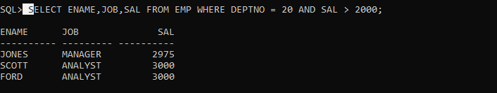

10. Find all salesman in dept30 whose salary is greater than or equal to 1500.

CREATE TABLE EMP

(

EMPNO NUMERIC(4) CONSTRAINT EMPNO_EMP_PK PRIMARY KEY,

ENAME VARCHAR(10),

JOB VARCHAR(9),

MGR NUMERIC(4),

HIREDATE DATE,

SAL NUMERIC(7,2),

COMM NUMERIC(7,2),

DEPTNO NUMERIC(2) CONSTRAINT DEPTNO_DEPT_FK REFERENCES DEPT(DEPTNO)

);

INSERT INTO EMP VALUES (7369,'SMITH','CLERK',7902,'17-DEC-80',800,NULL,20);

INSERT INTO EMP VALUES (7499,'ALLEN','SALESMAN',7698,'20-FEB-81',1600,300,30);

INSERT INTO EMP VALUES (7521,'WARD','SALESMAN',7698,'22-FEB-81',1250,500,30);

INSERT INTO EMP VALUES (7566,'JONES','MANAGER',7839,'02-APR-81',2975,NULL,20);

INSERT INTO EMP VALUES (7654,'MARTIN','SALESMAN',7698,'28-SEP-81',1250,1400,30);

INSERT INTO EMP VALUES (7698,'BLAKE','MANAGER',7839,'01-MAY-81',2850,NULL,30);

INSERT INTO EMP VALUES (7782,'CLARK','MANAGER',7839,'09-JUN-81',2450,NULL,10);

INSERT INTO EMP VALUES (7788,'SCOTT','ANALYST',7566,'19-APR-87',3000,NULL,20);

INSERT INTO EMP VALUES (7839,'KING','PRESIDENT',NULL,'17-NOV-81',5000,NULL,10);

INSERT INTO EMP VALUES (7844,'TURNER','SALESMAN',7698,'08-SEP-81',1500,0,30);

INSERT INTO EMP VALUES (7876,'ADAMS','CLERK',7788,'23-MAY-87',1100,NULL,20);

INSERT INTO EMP VALUES (7900,'JAMES','CLERK',7698,'03-DEC-81','950',NULL,30);

INSERT INTO EMP VALUES (7902,'FORD','ANALYST',7566,'03-DEC-81',3000,NULL,20);

INSERT INTO EMP VALUES (7934,'MILLER','CLERK',7782,'23-JAN-82',1300,NULL,10);

Ans: SELECT * FROM EMP WHERE JOB = 'SALESMAN'AND DEPTNO = 30 AND SAL >=1500;

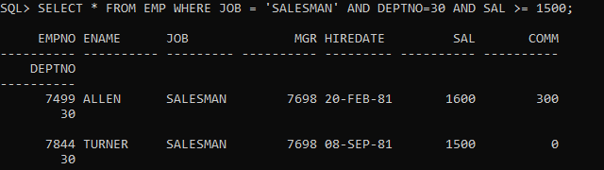

11. Find all the employees whose job is either a president or manager.

**QUERY :**

SELECT * FROM EMP WHERE JOB='MANAGER' OR JOB='PRESIDENT';

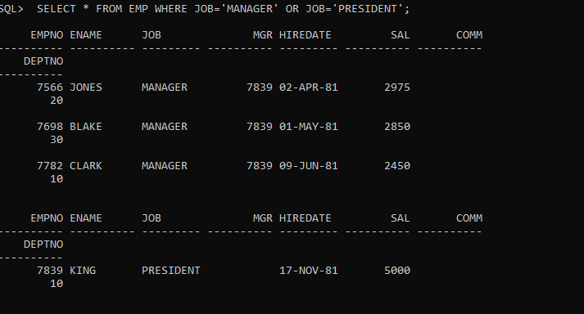

12. Find all managers who are not in dept 30.

**QUERY :**

SELECT * FROM EMP WHERE JOB='MANAGER'AND DEPTNO!=30;

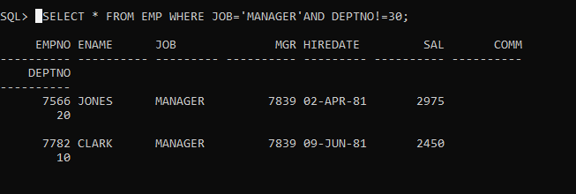

13. Find the details of all managers and clerks in dept 10.

**QUERY :**

SELECT ENAME,JOB,DEPTNO FROM EMP WHERE (JOB='MANAGER' OR JOB='CLERK') AND DEPTNO=10;

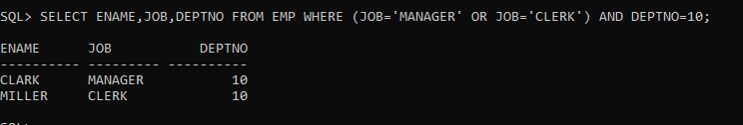

14.Find the details of all manager (in any dept) and all clerks in dept 10

**QUERY :**

SELECT ENAME,JOB,DEPTNO FROM EMP WHERE (JOB='MANAGER') OR (JOB='CLERK' AND DEPTNO=10);

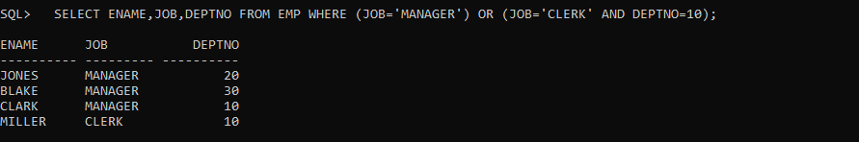

15.Find the details of all managers in dept 10 and all clerks in dept 20.

**QUERY :**

SELECT ENAME,JOB,DEPTNO FROM EMP WHERE (JOB='MANAGER' AND DEPTNO=10 ) OR (JOB='CLERK' AND DEPTNO=20);

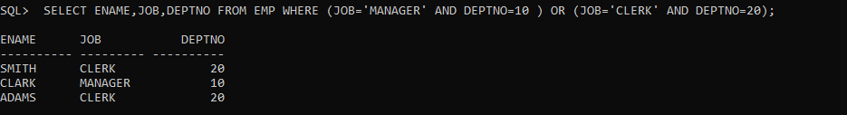

OR

**QUERY :**

SELECT ENAME,JOB,DEPTNO FROM EMP WHERE (JOB='MANAGER' AND DEPTNO=10 ) AND (JOB='CLERK' AND DEPTNO=20);



16.Find all employees who are neither clerks nor manager but whose salary is greater than or equal to Rs. 2000.

**QUERY :**

SELECT * FROM EMP WHERE (JOB!='MANAGER'AND JOB!='CLERK') AND SAL>=2000;

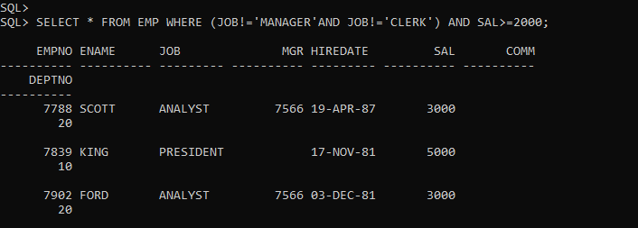

17. Find the employees who earns between Rs. 1200 and Rs.1400.

**QUERY :**

SELECT * FROM EMP WHERE SAL BETWEEN 1200 AND 1400;

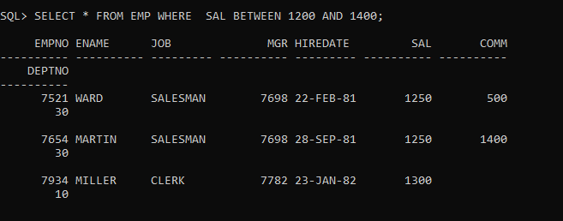

18. Find the employees who are clerks, analysts or salesman.

**QUERY :**

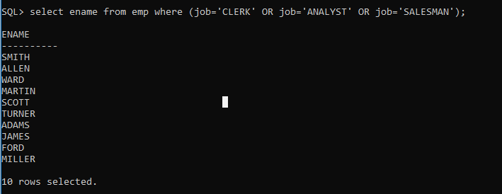

19. Find the employees who are not clerks, analyst or salesman.

**QUERY :**

SELECT * FROM EMP WHERE JOB NOT IN('CLERK','ANALYST','SALESMAN');

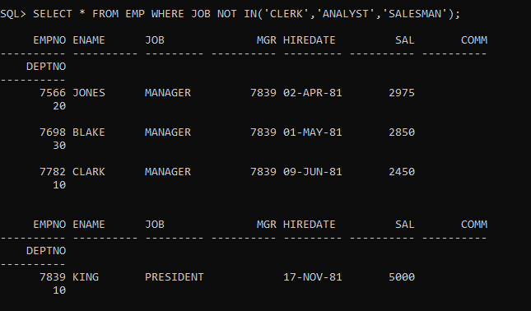

20.Find the employees who do not receive a commission i.e. commission is NULL.

**QUERY :**

SELECT ENAME ,DEPTNO FROM EMP WHERE COMM IS NULL;

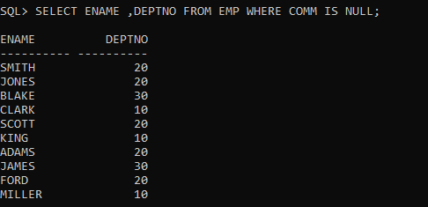

21. Find the employee whose commission is Rs. 0.

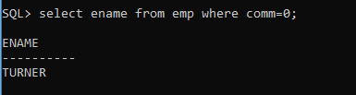

22.Find the different jobs of the employees receiving commission.

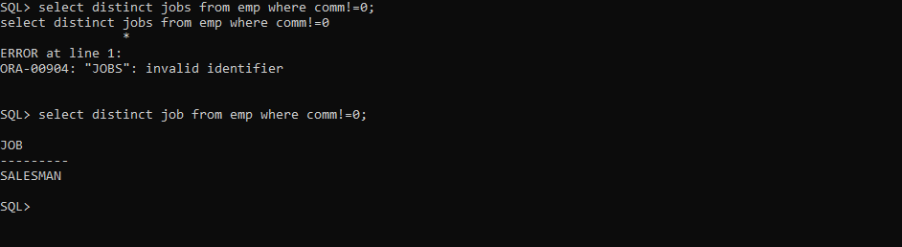

23. Find all employees who do not receive a commission or whose Commission is less than Rs. 100.

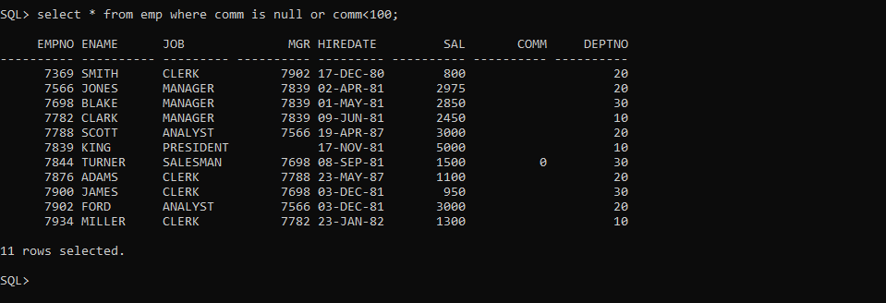

24. The employees who not receiving commission are entailed to Rs. 250, Show the net earnings of all employees. (find about **nvl() )**

* 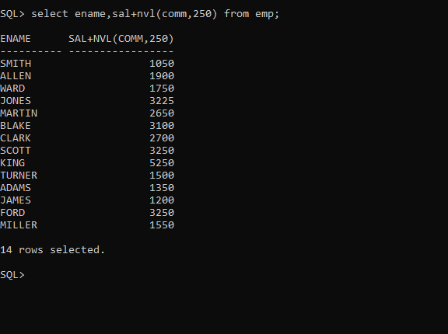

25. Find all employees whose total earnings are greater than Rs. 2000.

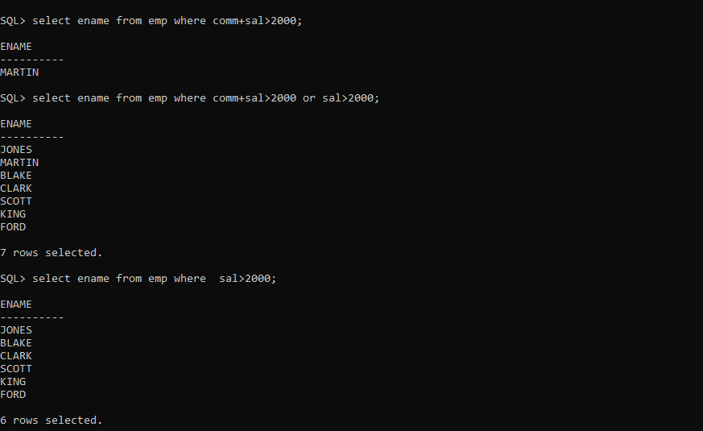

26. Find all employees whose names begin with m.

ANS:

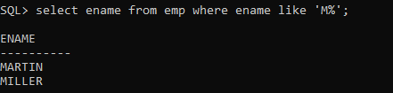

27.Find all employees whose names end with m.

ANS:

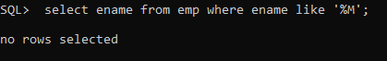

28.Find all employees whose names contain the letter m.

1ANS:



29.Find the employees whose names are 5 characters long and end with n.

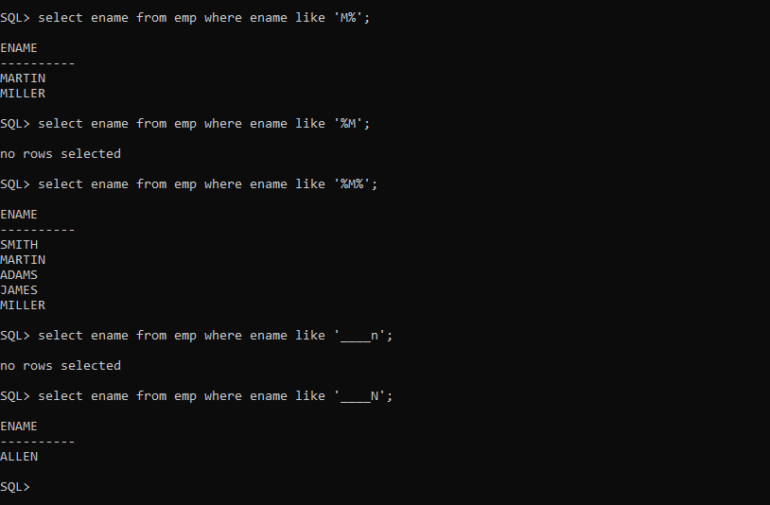

29.Find the employees whose names are 5 characters long and end with n.

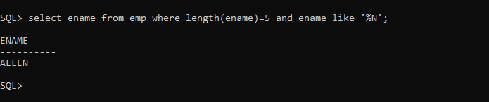

30. Find the employees who have the letter r as the third letter in their name.

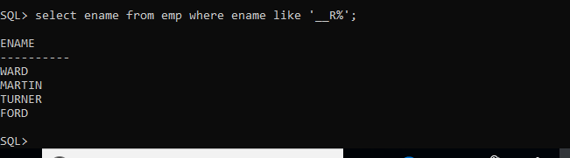

31. Find all employees hired in month of February (of any year).

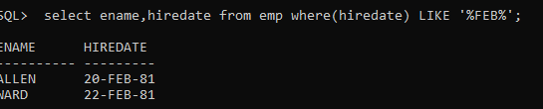

32. Find all employees who were hired on the last day of the month.

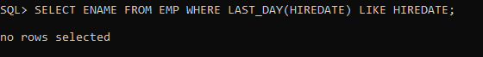

33. Find the employees who were hired more than 12 years ago.

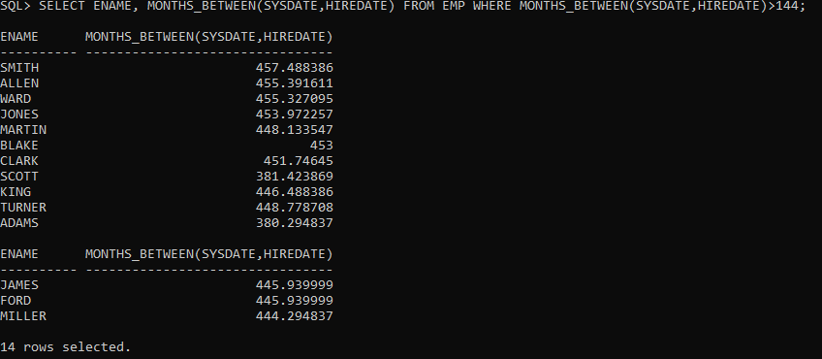

34. FIND THE MANAGERS HIRED IN THE YEAR 2007



35. Display the names and the jobs of all employees, separated by ‘,’(comma). For example

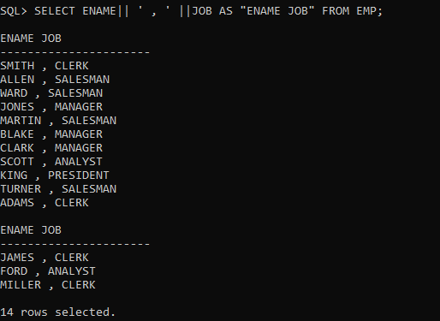

36. Display the names of all employees with the initial letter only in capitals.

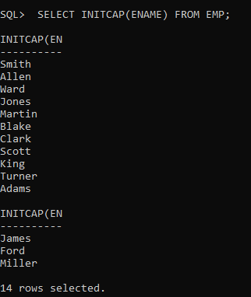

37. Display the names of all employees, right aligning them to 15 characters.

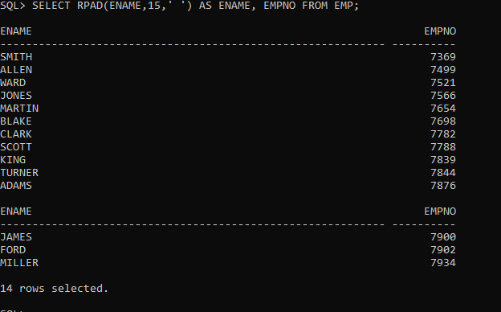

38. Display the names of all employees, padding them to right up-to 15 characters with ‘-‘

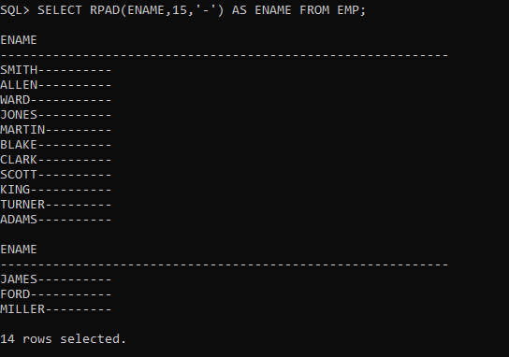

39. DISPLAY THE LENGTH OF THE NAME OF ALL EMPLOYEES

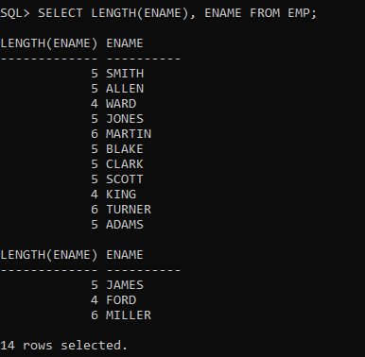

40. Display the names of all employees centering them with 20 characters.

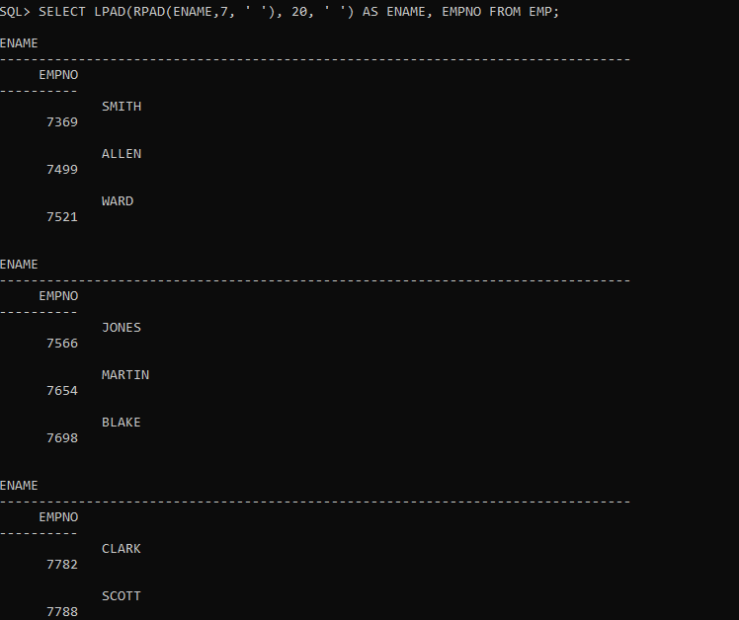

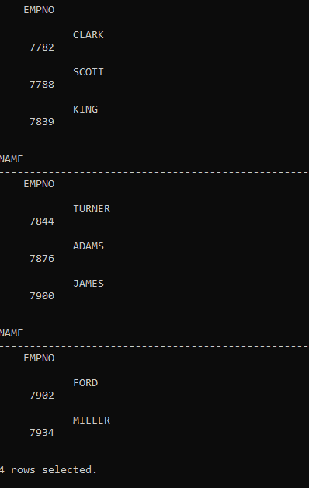

41.Display the names of all employees without any leading 'a'.

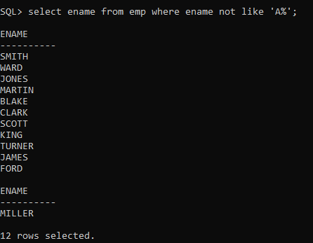

42.Display the names of all employees without any trailing 'r'.

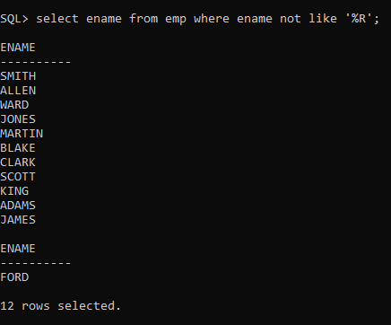

43.Show the first three characters of the names of all employees.

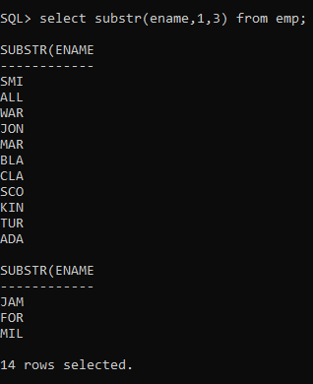

44..Show the last three characters of the names of all employees.

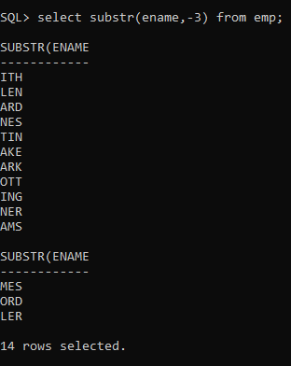

45.Display the names of all employees replacing any 'a' with 'e'.

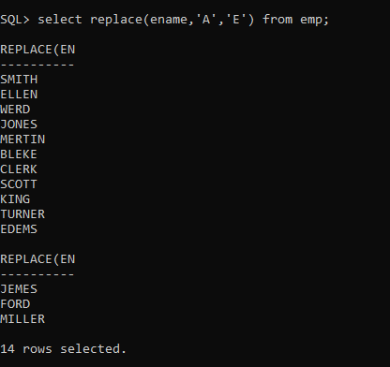

46.Display the names of all employees and the position at which the string 'ar' occurs in the name.

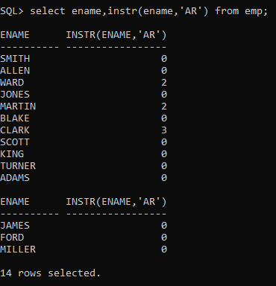

47.Show the salary of all employees rounding it to the nearest Rs. 1000. For example (3790 will be 4000)

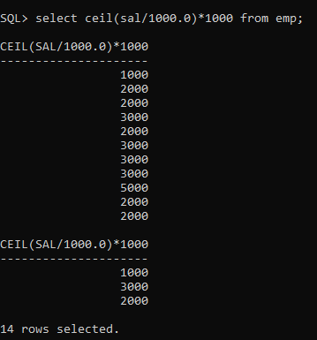

48.Show the daily salary of all employees assuming a month has 30 days.

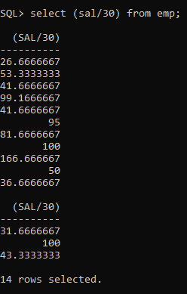

49.Display the name of all employees, and their bonus. Assume each Employee gets a bonus of 20 percent of his salary subject to the Maximum of Rs. 500.

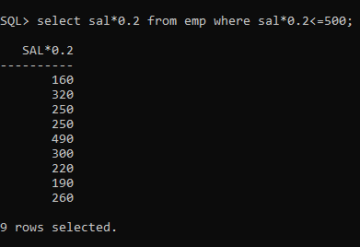

50.Display the name of all employees, and their bonus. Assume each employee gets a bonus of 20 percent of his salary subject to the Maximum of Rs. 200.

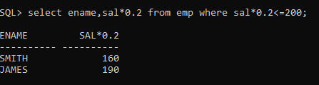

51. For each employee display the number of months passed since the employee joined the company.

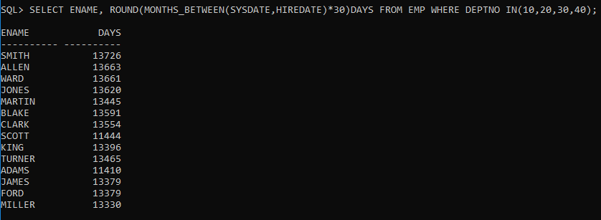

52. For each employee display the number of months passed since the Employee joined the company.

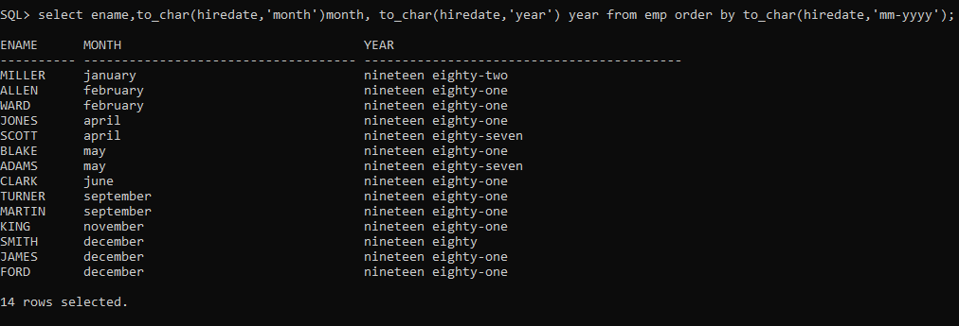

53. Display the tenure of service in the years, months and days for all Employees in character format. Assume every month has 30 days.

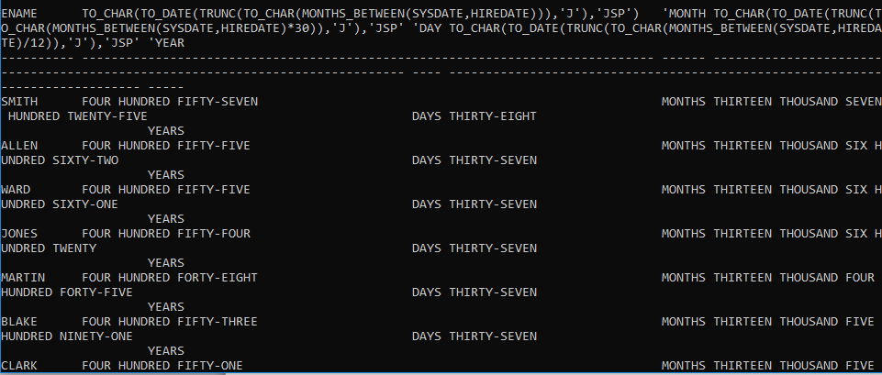

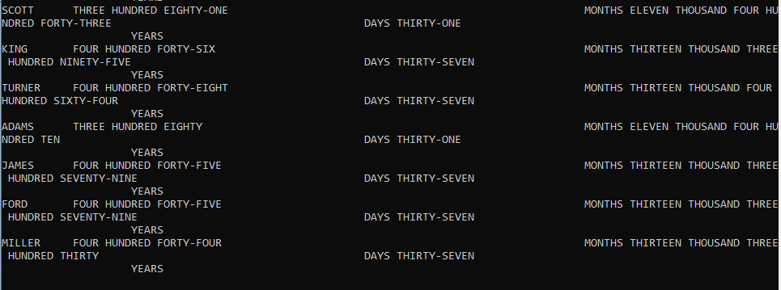

54. Display the employee details in the following manner. 'Miler joined on the twenty-third of January of the year nineteen hundred and eighty Two'.

55. Display the details of all employees, sorted on the names.

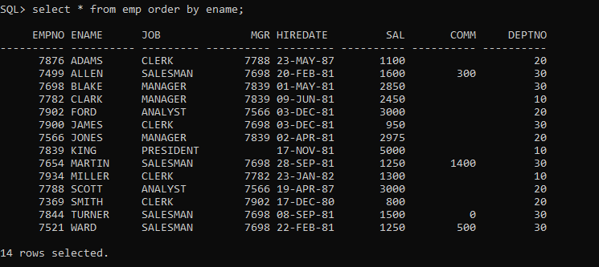

56. Display the name of all employees, based on their tenure, with the oldest employee coming first.

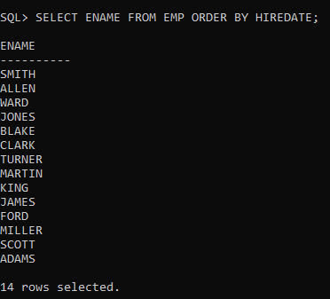

57. Display the names, job and salary of all employees sorted on jobs and salary.

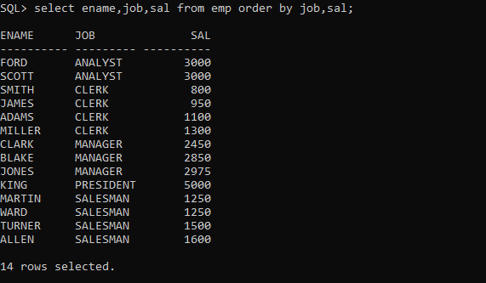

58. Display the names, job and salary of all employees, sorted on jobs and within job, sorted on the descending order of salary.

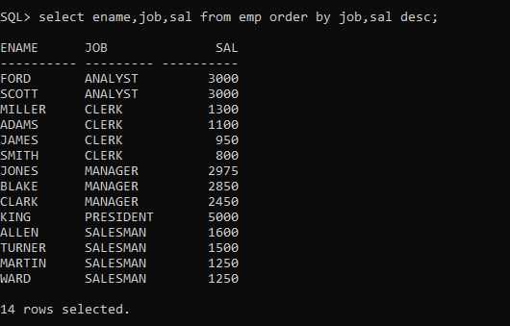

59. Display the names, job and salary of all employees, sorted on Descending order of job and within job, sorted on the descending order of salary.

60. Display the name, month and year of all employees, sorted on the month of their hire date irrespective of the year.

